Day 390 — ML Fundamentals Revision
Complete Revision Notes | AI vs ML • ML Paradigms • Mitchell's Framework • Datasets & Splitting
Learning goal: master foundational machine learning principles: articulate the precise distinctions between AI, ML, DL, and GenAI; categorize learning paradigms into Supervised, Unsupervised, and Reinforcement Learning; formalize learning problems using Tom Mitchell's <T, P, E> framework; navigate the complete end-to-end ML lifecycle; understand dataset anatomy, feature vectors, and target vectors; and execute statistically sound train/validation/test splits with stratification while rigorously preventing data leakage.
1. Artificial Intelligence (AI) vs. Machine Learning (ML)
Artificial Intelligence (AI) is the overarching multidisciplinary science of engineering computational systems capable of performing tasks that historically required biological human intelligence. This broad canopy encompasses symbolic knowledge representation, formal logic, heuristics, expert rule-based engines, natural language processing, computer vision, and robotics.
Machine Learning (ML) is a distinct mathematical subset of AI. Rather than relying on hardcoded, hand-crafted programmatic rules (e.g., nested IF-THEN conditions), ML algorithms ingest historical empirical observations (data) to automatically discover mathematical functions, statistical patterns, and decision boundaries. While Traditional Programming inputs rules and data to produce answers, Machine Learning inputs data and historical answers to output the learned rules (models).
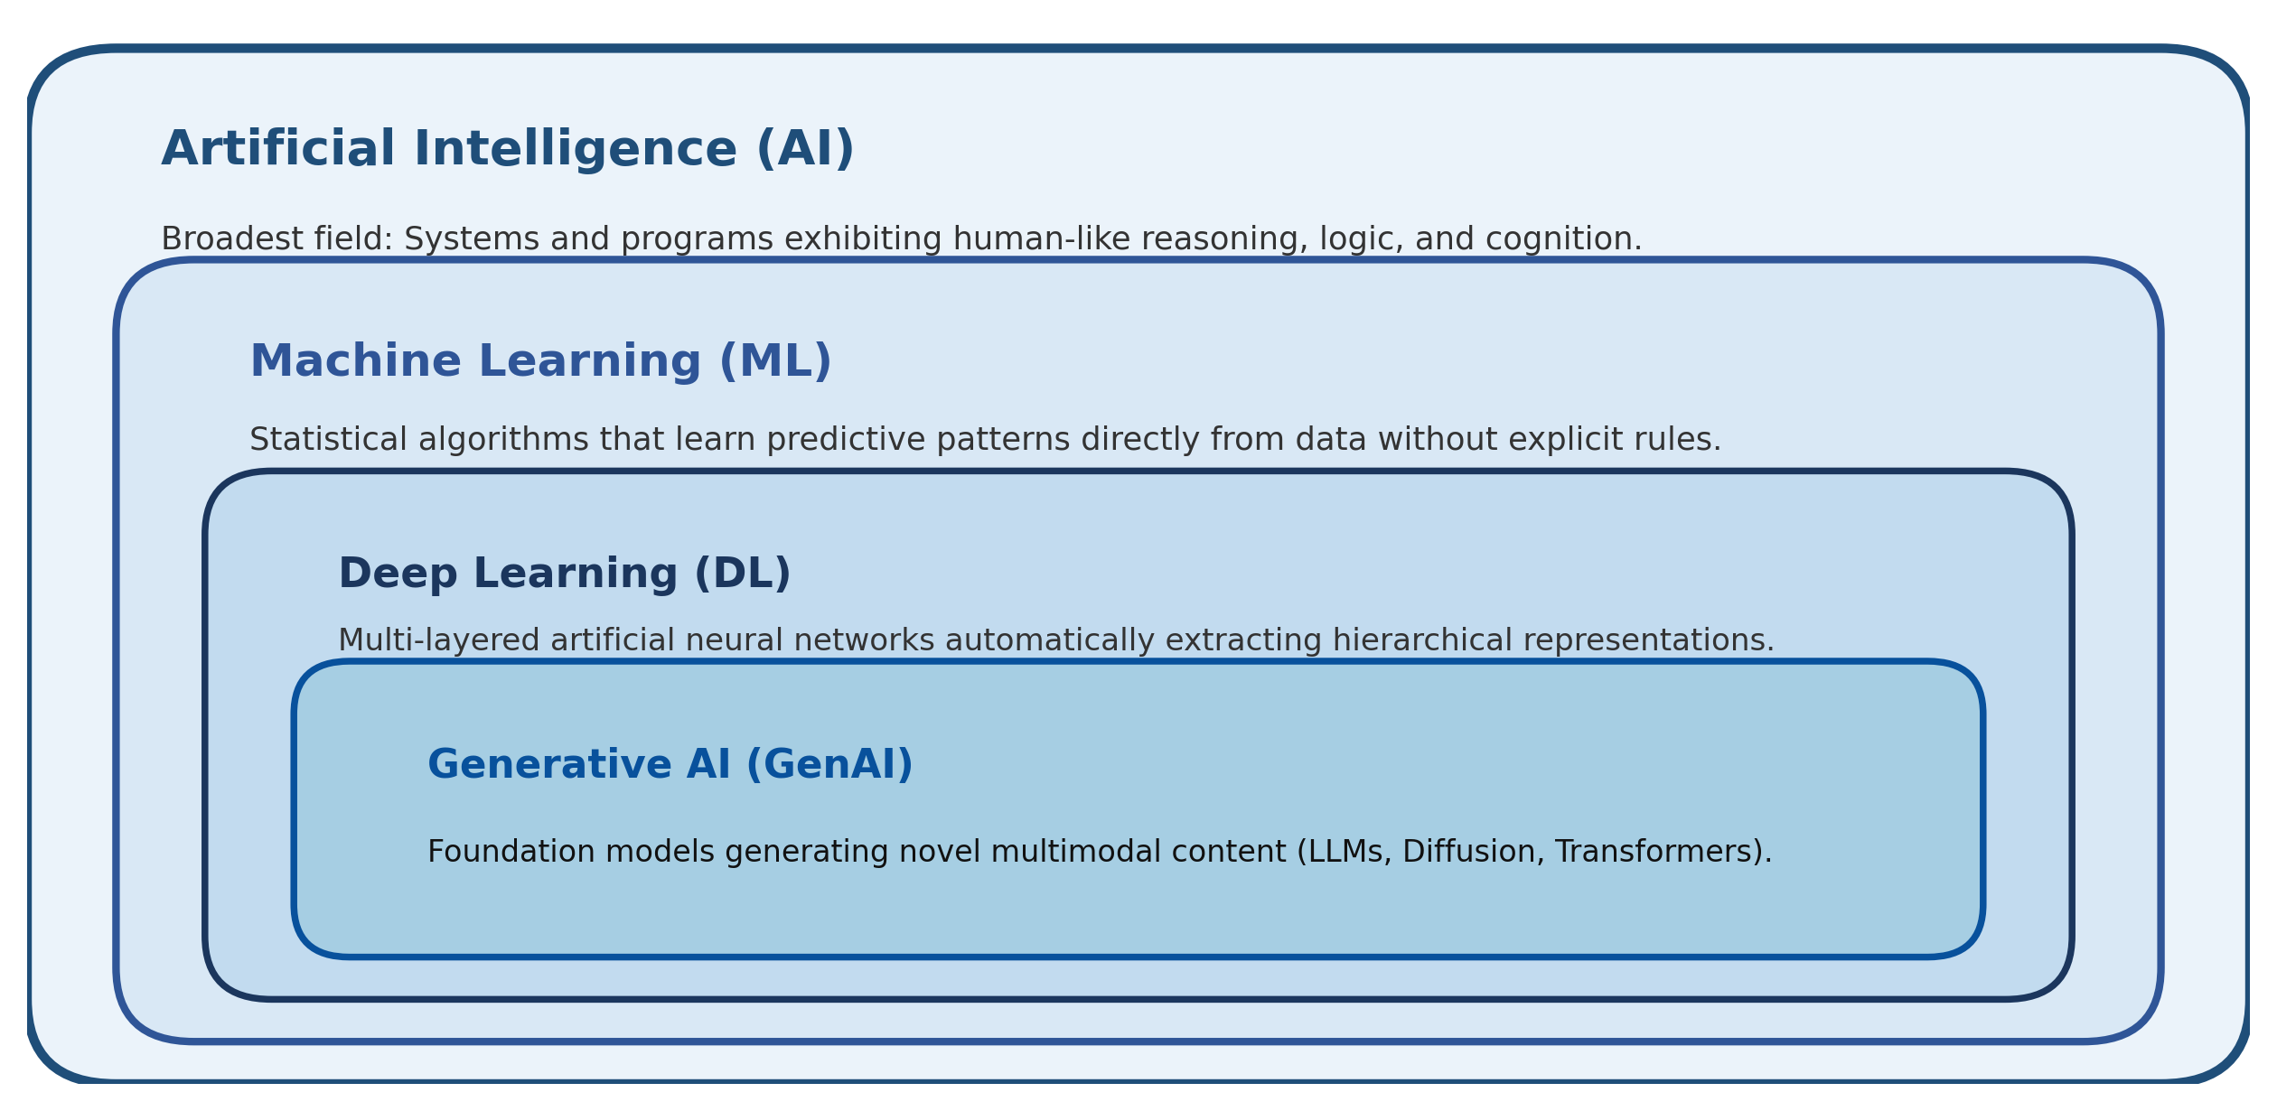
Figure 1. Concentric taxonomy of Artificial Intelligence, Machine Learning, Deep Learning, and Generative AI.
Paradigm | Input to System | System Mechanism | Primary Output | Brittleness / Scalability
Traditional Programming | Data + Handcrafted Rules | Deterministic algorithmic execution (IF-THEN, loops) | Answers / Computed Output | Extremely brittle; breaks when unanticipated edge cases occur
Machine Learning (ML) | Data + Observed Answers (Labels) | Statistical optimization & pattern extraction | Learned Rules / Model Function f(x) | Resilient; generalizes to unseen observations through statistical learning
Deep Learning (DL) | Raw High-Dimensional Data + Labels | Hierarchical feature representation via neural nets | End-to-End Latent Representations | Scales exceptionally well with massive datasets and GPU compute
Generative AI (GenAI) | Massive Multimodal Pretraining Data | Self-supervised next-token/diffusion prediction | Novel Synthetic Media / Text Generation | Broad cross-domain capabilities; prone to hallucinations without grounding

2. The Three Primary Paradigms of Machine Learning
Machine learning problems are categorized into three primary learning paradigms based on the nature of the feedback signal provided to the learning algorithm: Supervised Learning (explicit labeled supervision), Unsupervised Learning (absence of supervision), and Reinforcement Learning (trial-and-error reward feedback).
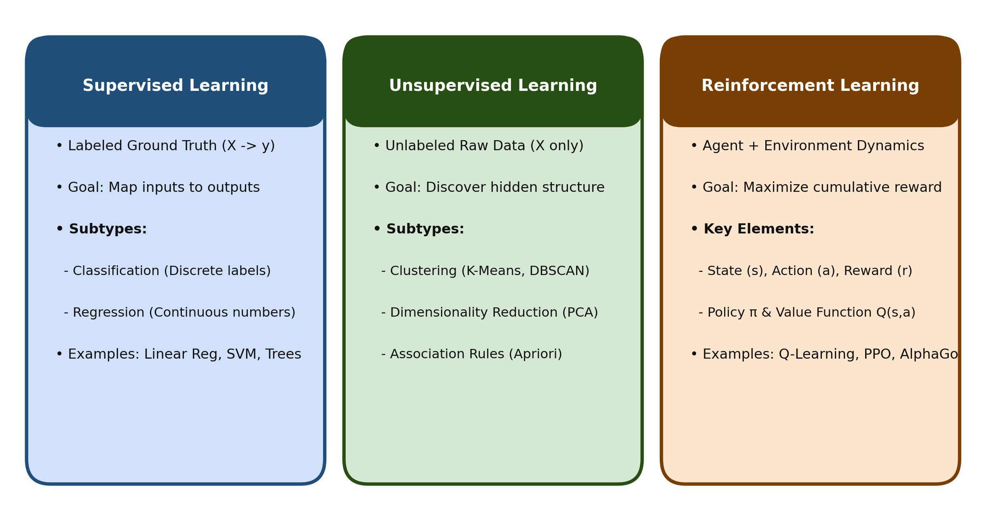
Figure 2. High-level architecture and task breakdown of the three primary Machine Learning paradigms.
Dimension | Supervised Learning | Unsupervised Learning | Reinforcement Learning
Training Data Signal | Pairs of input features and target labels: (X, y) | Unlabeled input features only: (X) | Agent interacts with Environment via State-Action-Reward: (s, a, r, s')
Core Mathematical Goal | Learn mapping function: y ≈ f(X; θ) | Discover underlying probability density P(X) or manifold | Learn optimal policy π*(a|s) that maximizes expected cumulative discounted reward
Primary Task Subtypes | Classification (discrete) & Regression (continuous) | Clustering, Dimensionality Reduction, Anomaly Detection | Policy Gradient, Q-Learning, Actor-Critic, Model-Based Control
Evaluation Feedback | Immediate direct loss: (y_true − y_pred) | Intrinsic heuristic metrics (Silhouette, Reconstruction Loss) | Delayed scalar reward signals; credit assignment over long temporal trajectories
Common Algorithms | Linear/Ridge/Lasso, Logistic Reg, SVM, Random Forest, XGBoost | K-Means, DBSCAN, PCA, t-SNE, Isolation Forest, Autoencoders | Deep Q-Networks (DQN), Proximal Policy Optimization (PPO), SARSA, A3C
Real-World Application | Spam classification, house price forecasting, disease diagnosis | Customer market segmentation, fraud pattern discovery, compression | Autonomous driving control, robotics manipulation, chess/Go game engines

3. Supervised Learning: Classification vs. Regression
In supervised learning, the model is provided with a training set of input-output pairs D = {(x_i, y_i)} for i = 1 to n. The fundamental distinction between Supervised tasks lies entirely in the mathematical nature and measurement scale of the target variable y.
Attribute | Classification Tasks | Regression Tasks
Target Variable Type (y) | Qualitative / Discrete categorical class labels (y ∈ {0, 1} or y ∈ {C_1, ..., C_k}) | Quantitative / Continuous numerical values (y ∈ ℝ, uncountably infinite scale)
Model Output | Class probabilities (via Softmax / Sigmoid) or discrete class assignment | Continuous scalar estimate / prediction (real-valued number)
Sub-Classifications | Binary (2 classes), Multi-class (>2 classes), Multi-label (multiple tags per row) | Simple Linear (1 feature), Multiple Linear (>1 feature), Polynomial, Non-linear
Evaluation Metrics | Accuracy, Precision, Recall, F1-Score, ROC-AUC, Log-Loss, Confusion Matrix | Mean Squared Error (MSE), Root Mean Squared Error (RMSE), Mean Absolute Error (MAE), R²
Decision Surface | Separating hyperplanes or non-linear decision boundaries partitioning space | Best-fit continuous curve, plane, or multi-dimensional regression surface
Concrete Examples | Detecting fraudulent transactions (Fraud / Legitimate); Tumor malignancy (Malignant / Benign) | Forecasting quarterly corporate revenue; Predicting residential real estate valuation

4. Semi-Supervised & Self-Supervised Learning
In industrial settings, acquiring unlabeled data is virtually free (e.g., scraping billions of web pages or medical scans), whereas acquiring ground-truth labels requires expensive, error-prone human domain experts. Two modern paradigms bridge this economic and computational divide.
Paradigm | Core Formulation | Standard Training Strategy | Impact on Modern AI
Semi-Supervised Learning | Dataset contains a tiny fraction of labeled data (X_L, y_L) and a massive pool of unlabeled data (X_U), where |X_U| >> |X_L|. | Pseudo-labeling: Train base model on (X_L, y_L), predict labels on X_U, filter high-confidence predictions, and retrain jointly. | Drastically slashes manual data annotation expenses while boosting model generalization.
Self-Supervised Learning (SSL) | Unlabeled data generates its own supervisory signals by holding out parts of the input and training the model to predict them. | Masked Autoencoding / Next-Token Prediction: Mask words or image patches; model reconstructs the missing data. | The universal bedrock of Modern Large Language Models (GPT-4, Llama) and Vision Transformers.

5. Formalizing Machine Learning: Mitchell's Well-Posed Learning Problem
In his seminal 1997 textbook, computer scientist Tom M. Mitchell established the formal definition of a Well-Posed Machine Learning Problem: "A computer program is said to learn from experience E with respect to some class of tasks T and performance measure P, if its performance at tasks in T, as measured by P, improves with experience E."
Application | Task (T) | Performance Measure (P) | Experience (E)
Email Spam Filter | Classify incoming emails as spam or legitimate inbox mail | Precision, Recall, F1-Score, or percentage of emails correctly labeled | Historical database of emails with human-annotated spam/ham labels
Autonomous Vehicle Navigation | Steer, accelerate, and brake safely along roadways | Mean distance traveled before human disengagement / collision rate | Sensor logs, camera video streams, and human teleoperation driving sessions
E-Commerce Credit Fraud Detection | Identify whether an incoming credit transaction is fraudulent | Area Under the Precision-Recall Curve (PR-AUC) and monetary loss prevented | Historical database of authenticated and charged-back credit card transactions
Medical Image Diagnosis | Detect malignant pulmonary nodules in thoracic CT scans | Sensitivity (Recall) at a fixed specificity threshold (ROC-AUC) | Historical archive of thoracic CT scans confirmed via surgical biopsy results

6. The End-to-End Machine Learning Workflow
Building robust machine learning systems is an iterative, engineering-intensive scientific lifecycle. Model training represents only a modest fraction of the total technical investment; data quality, problem formulation, and continuous monitoring dictate real-world success.
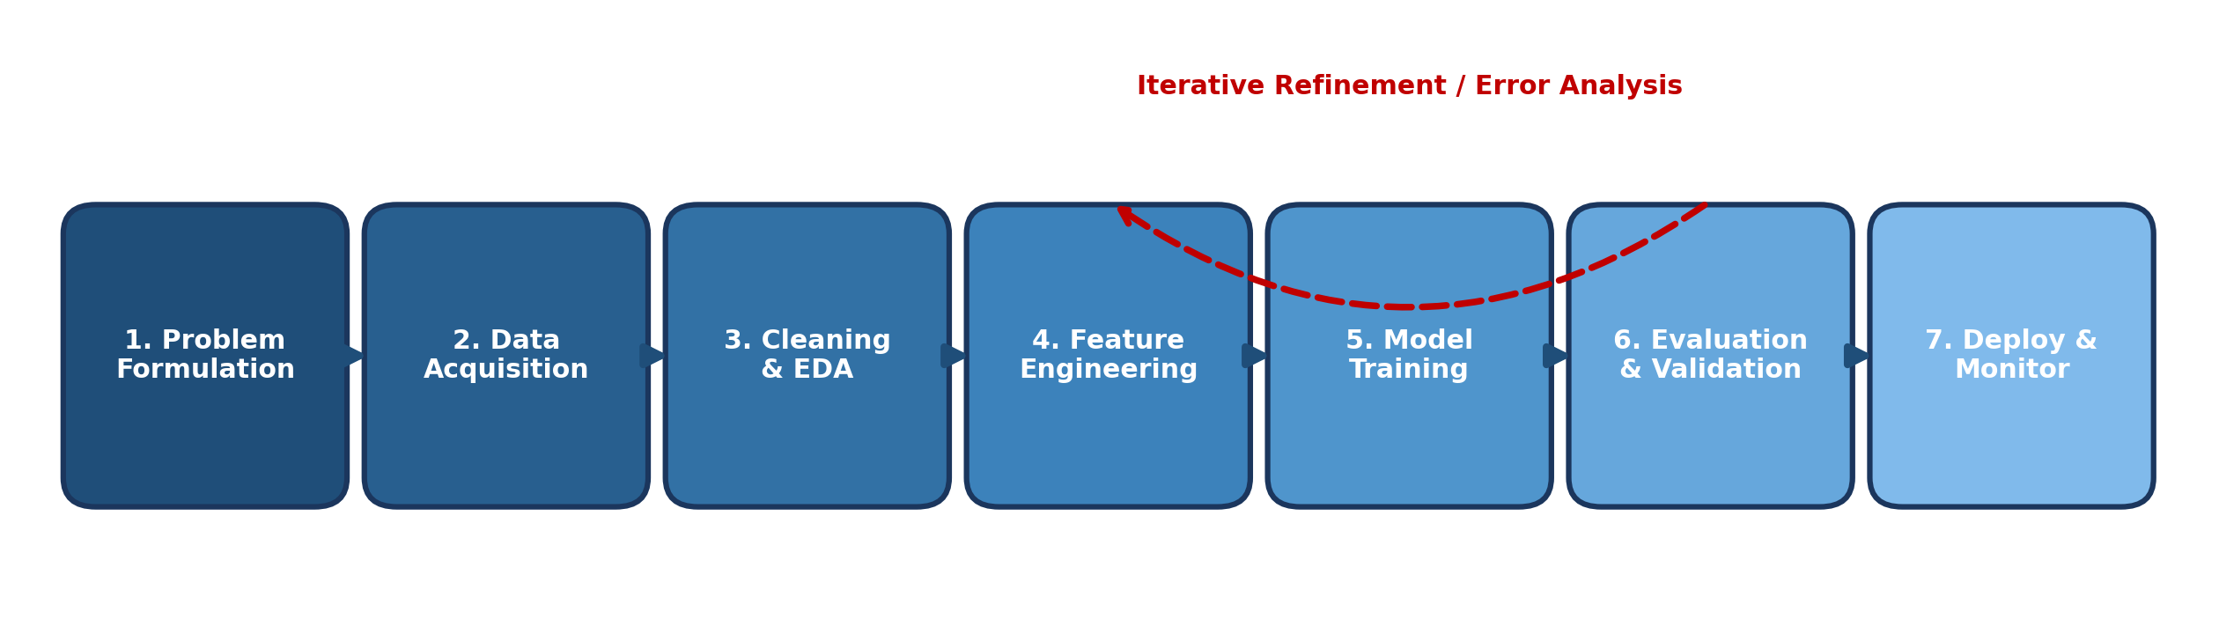
Figure 3. The seven sequential stages of the production Machine Learning development lifecycle.
Stage | Key Activities & Milestones | Primary Artifacts & Deliverables
1. Problem Formulation | Translate ambiguous business goals into mathematical ML objectives; establish baseline heuristics | Target definition (Metric P), success criteria, cost-benefit analysis
2. Data Acquisition & Ingestion | Query relational databases (SQL), stream Kafka logs, scrape web feeds; assess licensing | Raw tabular datasets, S3 data lake storage, data catalog definitions
3. Cleaning & Exploratory Analysis | Profile distributions, treat missing values, detect anomalies, quantify skewness and correlation | Data profiling report, missingness strategy, initial hypothesis backlog
4. Feature Engineering & Scaling | Extract domain ratios, encode categoricals, transform skewed values, isolate train scalers | Feature store, Scikit-Learn ColumnTransformer pipeline
5. Model Selection & Training | Train baseline models, conduct cross-validation, optimize hyperparameter grids (Optuna) | Trained model weights, validation loss curves, hyperparameter audit
6. Evaluation & Error Analysis | Inspect confusion matrices, evaluate residual diagnostics, audit fairness and edge cases | Model performance card, confusion matrix, error breakdown logs
7. Deployment & Monitoring | Containerize inference pipeline (Docker/FastAPI), track concept drift and inference latency | REST API endpoints, Prometheus/Grafana drift monitoring dashboards

7. Dataset Anatomy: Features, Feature Vectors, and Target Labels
In tabular machine learning, a dataset is mathematically conceptualized as a design matrix X and a target vector y. Every row represents an individual observation (instance/sample), while every column corresponds to a measurable property (feature/attribute).
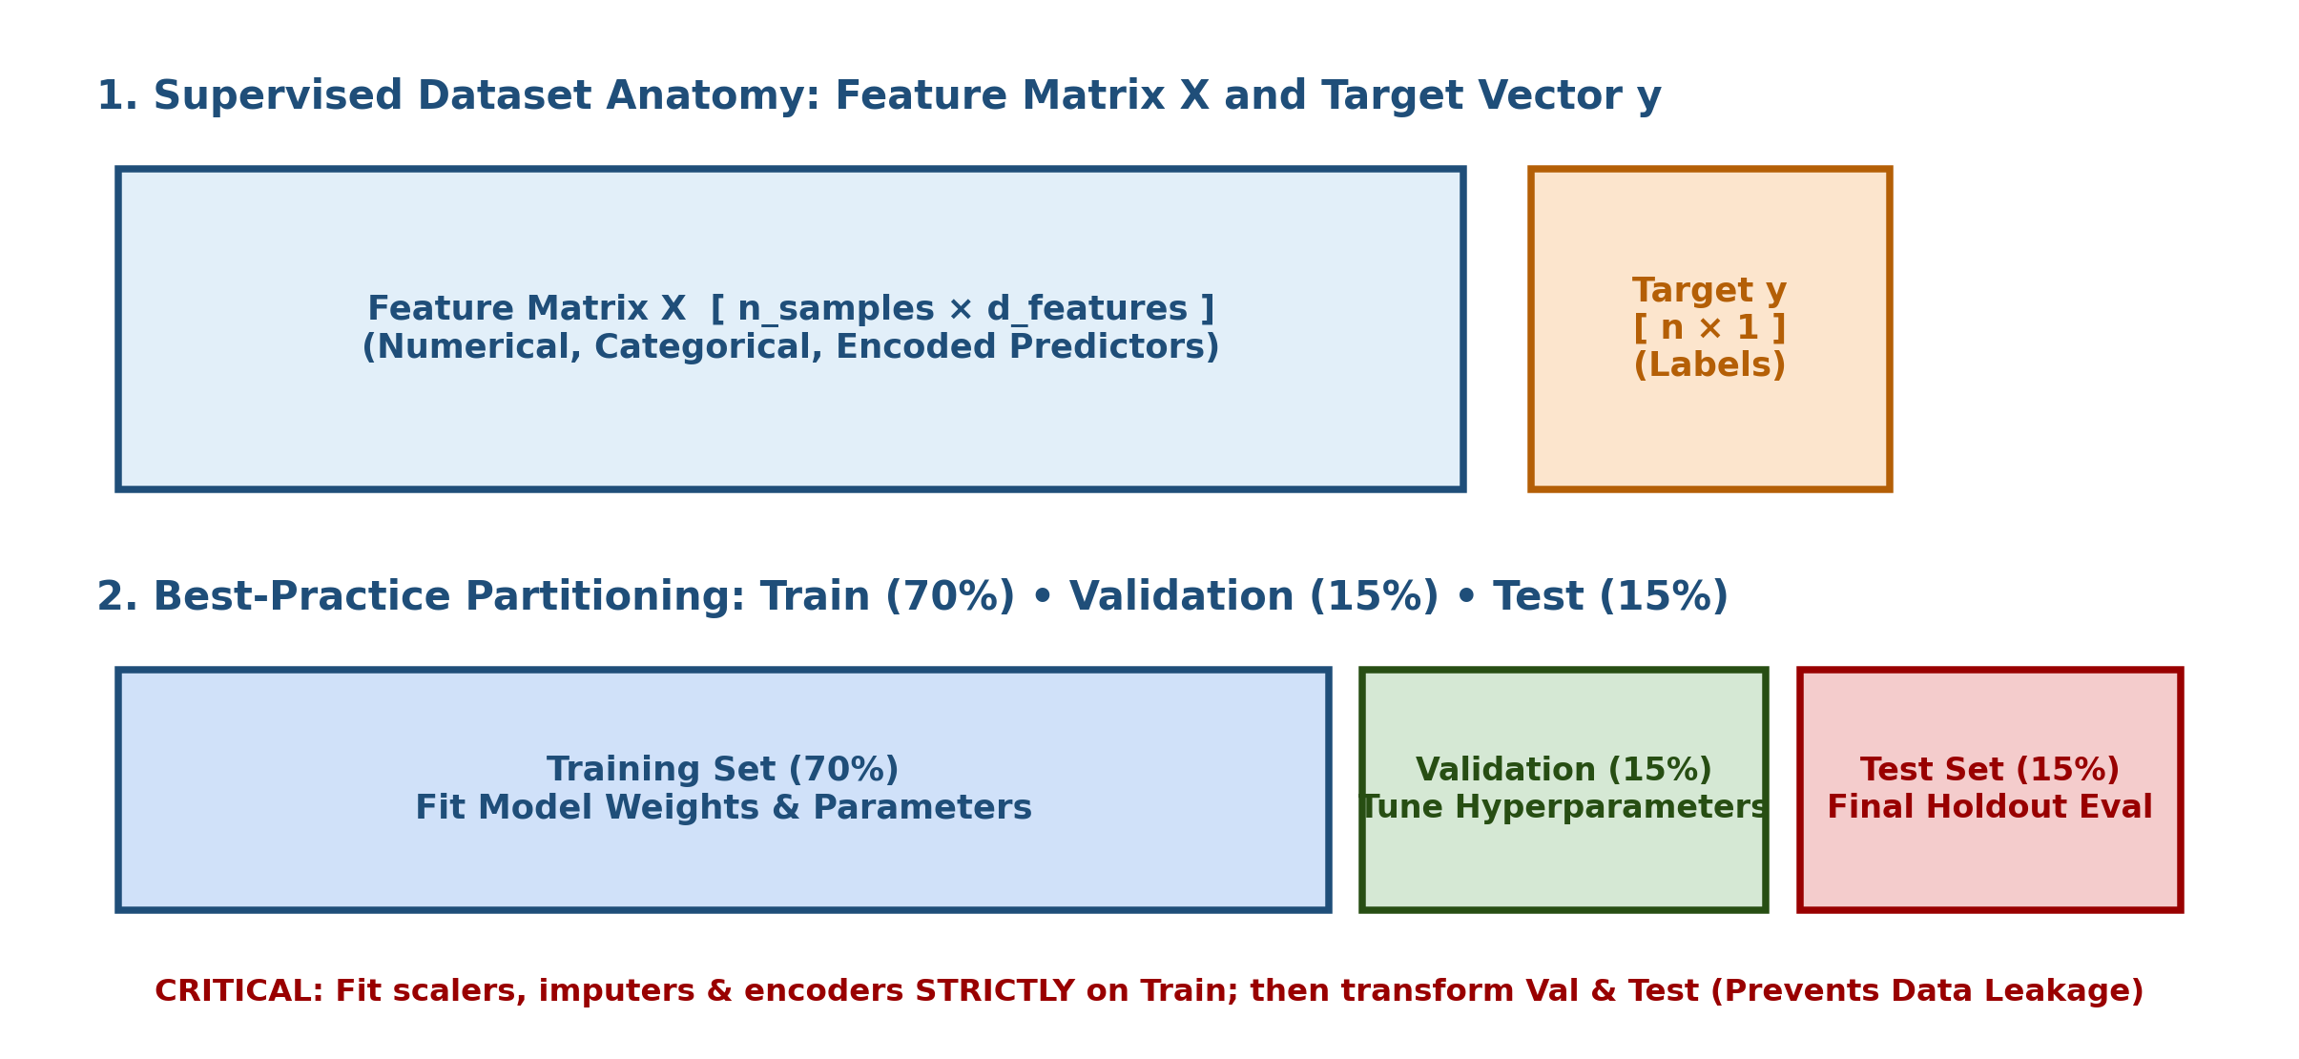
Figure 4. Design matrix anatomy and best-practice Train-Validation-Test splitting partition.
Mathematical Term | Notation | Shape / Dimension | Concrete Practical Meaning
Dataset (Design Matrix) | X | [n_samples × d_features] | The two-dimensional tabular matrix containing all predictor attributes across n records
Feature Vector | x_i | [d_features × 1] | The column vector representing all measurable properties for a single specific observation i
Target Vector | y | [n_samples × 1] | The ground-truth column containing historical outcomes the model is tasked with predicting
Sample / Instance | i | Row index: i ∈ {1, ..., n} | An individual independent entity under study (e.g., one customer, patient, or transaction)
Feature Dimension | d | Integer scalar | The total number of input variables; high dimensionality (d >> n) triggers the curse of dimensionality

8. The Train-Validation-Test Split Strategy
The central goal of machine learning is generalization: performing accurately on novel, unseen data generated by the same underlying distribution. Evaluating a model on the same data used to train it produces an overly optimistic, deceptive performance estimate (data memorization/overfitting). A rigorous machine learning workflow partitions data into three disjoint, non-overlapping subsets.
Partition Set | Standard Proportion | Primary Responsibility | Critical Usage Rules
Training Set | 60% – 80% | Optimizing model internal parameters (weights, coefficients, decision splits) | Never evaluate final generalization on this set; high score may reflect memorization.
Validation Set | 10% – 20% | Hyperparameter tuning, model architecture selection, early stopping in neural nets | Can introduce subtle optimization leakage if reused across thousands of tuning trials.
Test Set (Holdout) | 10% – 20% | Unbiased final proxy for real-world deployment performance | Locked in a vault; evaluated strictly ONCE at the end of the project to verify claims.

9. Stratified Splitting & Imbalanced Data Handling
Random splitting assumes observations are uniformly distributed across classes. However, in imbalanced domains (e.g., credit card fraud where only 0.2% of transactions are fraudulent, or rare disease diagnosis), purely random sampling can yield training or test sets with zero minority class instances. Stratified splitting preserves the exact class proportion across all subsets.
from sklearn.model_selection import train_test_split
import numpy as np
# Stratified Split Example: Preserving 95:5 Class Imbalance
X = np.random.randn(1000, 10)
y = np.array([0] * 950 + [1] * 50) # 5% rare positive class
# 1. Stratified Train-Test Split (80% Train, 20% Holdout Test)
X_train, X_test, y_train, y_test = train_test_split(
X, y, test_size=0.20, random_state=42, stratify=y
)
print(f"Full Data Class Ratio: {np.mean(y==1):.4f}") # 0.0500
print(f"Train Set Class Ratio: {np.mean(y_train==1):.4f}") # 0.0500
print(f"Test Set Class Ratio: {np.mean(y_test==1):.4f}") # 0.0500

10. Data Leakage: Mechanisms, Consequences & Prevention
Data leakage is the insidious mistake of including information from outside the training dataset when training a model. A leaked model displays spectacular validation accuracy in development but catastrophic failure in real-world production.
Leakage Mechanism | How It Occurs | Catastrophic Consequence | Robust Prevention Strategy
Preprocessing Leakage | Calling fit_transform() on the entire dataset prior to splitting into train and test sets | Scaler learns the test set mean and min/max, leaking future distribution properties | Split data FIRST. Call fit_transform() only on Train; call transform() on Test.
Target Leakage | Including an input feature that is an artifact of the target label (e.g., 'Hospitalization_Discharge_Date') | Model relies on a feature that will never exist at the exact time inference is requested | Audit feature timelines; ensure all predictors are available before prediction.
Temporal Leakage | Using future data to predict the past (e.g., shuffling ordered stock prices in random K-Fold) | Model learns from future trends, violating the temporal arrow of causality | Use TimeSeriesSplit or PurgedGroupTimeSeriesSplit; never shuffle time-series.
Duplicate / Group Leakage | Observations from the exact same patient or group appear in both Train and Test sets | Model memorizes patient-specific idiosyncrasies rather than learning disease patterns | Use GroupKFold or GroupShuffleSplit grouped strictly by Entity / Patient ID.

11. K-Fold & Stratified K-Fold Cross-Validation
While a single train-test split is computationally inexpensive, performance estimates remain sensitive to the random partition chosen. K-Fold Cross-Validation provides a statistically stable estimate by systematically training K separate models on K different folds.
Cross-Validation Variant | How It Operates | Ideal Use Case
Standard K-Fold | Partitions data into K equal folds; iterates K times using 1 fold for validation and K-1 for training | Large, balanced tabular datasets where class frequencies are relatively uniform
Stratified K-Fold | Partitions data into K folds while ensuring every single fold contains identical target class distributions | Classification tasks, especially imbalanced datasets (e.g., disease diagnosis, churn)
Group K-Fold | Guarantees that no single group (e.g., patient, user, store) is split across both train and validation folds | Medical patient trials, multi-device IoT telemetry, hierarchical cluster data
TimeSeriesSplit | Expanding-window or rolling-window cross-validation that respects temporal causality (Train on past -> Test on future) | Financial stock forecasting, weather tracking, retail demand time-series

12. Inductive Bias, Generalization, and the No Free Lunch Theorem
Without prior assumptions about the nature of the target function, a learning algorithm has no rational justification for preferring one hypothesis over another. This foundational constraint is formalized by two core statistical learning concepts.
Theoretical Concept | Formal Definition | Machine Learning Consequence
Inductive Bias | The complete set of prior assumptions a machine learning algorithm uses to predict outputs on unseen inputs | Enables generalization. E.g., Linear Regression assumes linearity; Decision Trees assume orthogonal axis splits; CNNs assume spatial locality.
No Free Lunch (NFL) Theorem | Formulated by Wolpert & Macready (1997): Averaged across all possible data-generating distributions, every learning algorithm performs identically to random guessing. | There is no universally superior machine learning model. An algorithm's excellence on image classification implies nothing about its efficacy on tabular financial fraud.

13. Practical Project — Production-Ready ML Experiment Pipeline
Objective: build an end-to-end, modular Python framework that formalizes a machine learning problem under Mitchell's <T, P, E> framework, simulates an imbalanced real-world enterprise dataset, executes a stratified train/validation/test split, encapsulates preprocessing strictly within Scikit-Learn Pipelines to eliminate data leakage, and benchmarks multiple algorithms.
Project Structure:
ml_fundamentals_project/
|-- data/
| |-- customer_churn.csv
|-- outputs/
| |-- model_comparison.csv
| |-- pipeline_architecture.png
|-- main.py
|-- requirements.txt

requirements.txt:
numpy
pandas
scikit-learn
scipy

Complete main.py Script:
import numpy as np
import pandas as pd
from sklearn.model_selection import train_test_split, StratifiedKFold, cross_val_score
from sklearn.pipeline import Pipeline
from sklearn.compose import ColumnTransformer
from sklearn.preprocessing import StandardScaler, OneHotEncoder
from sklearn.impute import SimpleImputer
from sklearn.linear_model import LogisticRegression
from sklearn.ensemble import RandomForestClassifier
from sklearn.metrics import classification_report, roc_auc_score
class MLFundamentalsPipeline:
"""
Formalization under Mitchell's Framework:
- Task (T): Predict whether an enterprise subscriber will churn (Binary Classification: 0 or 1).
- Performance (P): Receiver Operating Characteristic AUC (ROC-AUC) & F1-Score on unseen test data.
- Experience (E): Historical multi-attribute tabular customer subscription logs.
"""
def __init__(self, n_samples=1000, random_state=42):
self.random_state = random_state
self.df = self._generate_synthetic_data(n_samples)
self.X_train = None
self.X_val = None
self.X_test = None
self.y_train = None
self.y_val = None
self.y_test = None
def _generate_synthetic_data(self, n):
np.random.seed(self.random_state)
tenure = np.random.exponential(scale=18, size=n).clip(1, 72)
monthly_charges = np.random.normal(loc=65, scale=25, size=n).clip(15, 130)
contract = np.random.choice(["Month-to-Month", "One-Year", "Two-Year"], size=n, p=[0.6, 0.25, 0.15])
support_tickets = np.random.poisson(lam=1.5, size=n)
# Churn probability driven by short tenure, high charges, month-to-month, and high tickets
logits = -2.0 - 0.05 * tenure + 0.02 * monthly_charges + 0.4 * support_tickets + (contract == "Month-to-Month") * 0.8
probs = 1 / (1 + np.exp(-logits))
churn = (np.random.rand(n) < probs).astype(int)
df = pd.DataFrame({
"Tenure_Months": tenure.round(1),
"Monthly_Charges": monthly_charges.round(2),
"Support_Tickets": support_tickets,
"Contract_Type": contract,
"Churn": churn
})
return df
def execute_leakage_free_split(self):
print("=== STEP 1: LEAKAGE-FREE STRATIFIED PARTITIONING ===")
X = self.df.drop(columns=["Churn"])
y = self.df["Churn"]
# 1. First Split: 80% Train+Val, 20% Holdout Test
X_temp, self.X_test, y_temp, self.y_test = train_test_split(
X, y, test_size=0.20, random_state=self.random_state, stratify=y
)
# 2. Second Split: 75% of temp -> 60% Train; 25% of temp -> 20% Val
self.X_train, self.X_val, self.y_train, self.y_val = train_test_split(
X_temp, y_temp, test_size=0.25, random_state=self.random_state, stratify=y_temp
)
print(f"Training Set Shape: {self.X_train.shape} (Class 1 Ratio: {self.y_train.mean():.3f})")
print(f"Validation Set Shape: {self.X_val.shape} (Class 1 Ratio: {self.y_val.mean():.3f})")
print(f"Holdout Test Shape: {self.X_test.shape} (Class 1 Ratio: {self.y_test.mean():.3f})")
def build_preprocessing_pipeline(self):
numeric_features = ["Tenure_Months", "Monthly_Charges", "Support_Tickets"]
categorical_features = ["Contract_Type"]
numeric_transformer = Pipeline(steps=[
("imputer", SimpleImputer(strategy="median")),
("scaler", StandardScaler())
])
categorical_transformer = Pipeline(steps=[
("imputer", SimpleImputer(strategy="most_frequent")),
("onehot", OneHotEncoder(drop="first", handle_unknown="ignore"))
])
preprocessor = ColumnTransformer(transformers=[
("num", numeric_transformer, numeric_features),
("cat", categorical_transformer, categorical_features)
])
return preprocessor
def train_and_benchmark(self):
print("\n=== STEP 2: LEAKAGE-FREE MODEL BENCHMARKING ===")
preprocessor = self.build_preprocessing_pipeline()
models = {
"Logistic Regression": LogisticRegression(random_state=self.random_state),
"Random Forest": RandomForestClassifier(n_estimators=100, max_depth=6, random_state=self.random_state)
}
cv = StratifiedKFold(n_splits=5, shuffle=True, random_state=self.random_state)
for name, clf in models.items():
pipe = Pipeline(steps=[
("preprocessor", preprocessor),
("classifier", clf)
])
# 5-Fold Stratified Cross Validation on Training Data
cv_scores = cross_val_score(pipe, self.X_train, self.y_train, cv=cv, scoring="roc_auc")
print(f"{name:20s} | 5-Fold CV ROC-AUC: {cv_scores.mean():.4f} (±{cv_scores.std():.4f})")
# Fit on complete training partition
pipe.fit(self.X_train, self.y_train)
# Evaluate on Holdout Test Set
y_pred = pipe.predict(self.X_test)
y_prob = pipe.predict_proba(self.X_test)[:, 1]
test_auc = roc_auc_score(self.y_test, y_prob)
print(f"{name:20s} | Holdout Test ROC-AUC: {test_auc:.4f}")
def run(self):
self.execute_leakage_free_split()
self.train_and_benchmark()
print("\nProduction-style ML fundamentals workflow executed successfully.")
if __name__ == "__main__":
pipeline = MLFundamentalsPipeline(n_samples=1200)
pipeline.run()

14. Common Mistakes & Anti-Patterns to Avoid
1. Fitting Scalers Before Splitting: Calling StandardScaler().fit_transform(X) on the entire dataset before train_test_split leaks test set parameters.
2. Evaluating Models on Training Data: Reporting 99.8% training accuracy while the test accuracy languishes at 55% due to catastrophic overfitting.
3. Using Random Split on Imbalanced Data: Failing to set stratify=y on highly skewed datasets, producing test partitions devoid of the minority class.
4. Randomly Shuffling Time-Series Data: Permuting ordered financial or sequential records, effectively allowing the model to train on future knowledge to predict the past.
5. Optimizing Hyperparameters on the Test Set: Tuning model parameters directly against the holdout set, completely compromising its unbiased evaluation integrity.
6. Neglecting Group Boundaries: Splitting multiple chest X-rays from the same patient across both training and validation sets (violating sample independence).
7. Confusing Classification and Regression Metrics: Evaluating a multi-class classifier using Mean Squared Error or evaluating a regression model using ROC-AUC.
8. Ignoring the Baseline Heuristic: Building an elaborate neural network without first checking if a dummy Zero-R classifier (always predicting the majority class) achieves 95% accuracy.
15. Quick Revision — Key Differences
Comparison | First Concept | Second Concept
AI vs Machine Learning | Broad superset: machines mimicking human intelligence and cognitive behavior | Mathematical subset of AI: algorithms learning patterns directly from data
Supervised vs Unsupervised | Learns from explicitly labeled training pairs (X, y) | Discovers innate structures, clusters, and manifolds from unlabeled data (X only)
Classification vs Regression | Predicts qualitative, discrete class labels (e.g., Spam vs Ham) | Predicts quantitative, continuous numerical scalars (e.g., House Price)
Validation Set vs Test Set | Used iteratively to tune hyperparameters and select model architectures | Used strictly once at the end as an unbiased proxy for real-world deployment
Random Split vs Stratified Split | Partitions rows purely by uniform chance; risks skewing class proportions | Guarantees identical target class percentage across train, val, and test partitions
K-Fold vs Stratified K-Fold | Splits data into K equal folds regardless of target class frequencies | Splits data into K folds while preserving exact label proportions in every single fold
Parameters vs Hyperparameters | Internal model weights learned directly from data during training (e.g., weights w, b) | External configuration knobs tuned before training starts (e.g., learning rate, max_depth)

16. Important Formulas & Conceptual Cheat Sheet
Concept | Mathematical Formulation / Definition | Key Principle
Mitchell's ML Definition | P(T) improves with experience E | Formal mathematical baseline for all learning algorithms
Generalization Error | E_gen(h) = E_(x,y)~D [ L(h(x), y) ] | Expected loss over the true unseen data-generating distribution
Empirical Risk Minimization | R_emp(h) = (1 / n) Σ [i=1 to n] L(h(x_i), y_i) | Minimizing average loss over observed training samples
Train-Test Partition Rule | D_train ∩ D_test = ∅, D_train ∪ D_test = D | Subsets must be strictly mutually exclusive and exhaustive
Stratified Sampling Ratio | P(y = c | D_train) = P(y = c | D_test) = P(y = c | D) | Class prior probability must remain invariant across partitions
Standard K-Fold Cross-Val | CV_Score = (1 / K) Σ [k=1 to K] Metric(Model_k, Fold_k) | Unbiased variance reduction for small-to-medium datasets

17. Interview / Viva Questions
What is the fundamental difference between AI, Machine Learning, and Deep Learning?
AI is the broad science of simulating human intelligence; ML is a subset of AI where algorithms learn rules from data; DL is a subset of ML utilizing multi-layered artificial neural networks to learn hierarchical feature representations.
Explain Tom Mitchell's formal definition of a Machine Learning problem.
A computer program is said to learn from experience E with respect to task T and performance measure P, if its performance at task T, as measured by P, improves with experience E.
What is the difference between Supervised, Unsupervised, and Reinforcement Learning?
Supervised learning trains on labeled input-output pairs (X, y); Unsupervised learning discovers hidden patterns from unlabeled inputs (X); Reinforcement learning optimizes an agent's policy via environmental trial-and-error rewards.
How do Classification and Regression tasks differ mathematically?
Classification maps inputs to discrete categorical class labels; Regression maps inputs to continuous real-valued numbers.
What is the difference between Semi-Supervised and Self-Supervised Learning?
Semi-supervised uses a small set of labeled data alongside a large pool of unlabeled data; Self-supervised generates supervisory labels directly from the structure of the unlabeled data itself (e.g., masking tokens).
Why can't we evaluate a machine learning model on the training set?
Evaluating on training data measures memorization rather than generalization. A model can overfit completely, scoring 100% on training data while failing catastrophically on unseen real-world data.
What are the specific roles of the Training, Validation, and Test sets?
Training set fits model weights; Validation set tunes hyperparameters and selects architectures; Test set provides an unbiased final evaluation of generalization.
What is Data Leakage and how does it compromise model integrity?
Data leakage occurs when information from outside the training set influences the model. It causes deceptively high validation scores that collapse in production.
Why is fitting a scaler on the entire dataset before splitting considered leakage?
Because the scaler computes the mean, standard deviation, or min/max using test set data, subtly imparting future distribution knowledge to the training process.
When must you use Stratified Splitting instead of Random Splitting?
Whenever working with classification tasks, especially imbalanced datasets, to ensure that minority classes are represented in identical proportions across all splits.
What is K-Fold Cross-Validation and what problem does it solve?
It splits data into K equal partitions, training K models to evaluate performance across the entire dataset. It reduces metric variance caused by arbitrary single splits.
What is Group K-Fold and when is it mandatory?
Group K-Fold ensures all observations belonging to a specific entity (e.g., patient, user) stay strictly within one fold, preventing entity-level data leakage.
Why is random splitting inappropriate for Time-Series forecasting?
Random splitting breaks the temporal arrow of causality, allowing the model to peek into future trends to predict historical records. TimeSeriesSplit must be used.
What is Inductive Bias and why is it necessary for learning?
Inductive bias represents the prior assumptions an algorithm makes to generalize beyond training data. Without inductive bias, an algorithm cannot prefer any hypothesis over another.
State the No Free Lunch Theorem in Machine Learning.
Averaged across all possible data-generating problems, every learning algorithm performs identically to random guessing. No single model is universally superior.
What is the difference between Model Parameters and Model Hyperparameters?
Parameters are learned internally from data during training (e.g., weights w, b); Hyperparameters are external configuration settings tuned before training (e.g., learning rate).
What is the Dummy Classifier heuristic and why should it always be checked?
A simple baseline that always predicts the majority class or mean. In an imbalanced dataset with 98% class 0, a model claiming 98% accuracy may have learned nothing.
What is the difference between Multi-Class and Multi-Label Classification?
Multi-class assigns each sample exactly one mutually exclusive class from >2 options; Multi-label assigns each sample any number of non-exclusive labels simultaneously.
How does Scikit-Learn's Pipeline prevent data leakage during Cross-Validation?
The Pipeline ensures that preprocessing steps (scaling, imputing) are fitted strictly on the K-1 training folds and only applied to transform the K-th validation fold.
What is Target Leakage? Give a concrete medical or financial example.
Using a predictor that directly results from the target outcome. Example: using 'Chemotherapy_Prescribed = Yes' to predict cancer diagnosis before clinical lab tests.
18. Coding Practice
1. Formalize three diverse real-world problems (fraud detection, house price prediction, autonomous drone landing) using Mitchell's <T, P, E> framework.
2. Generate a synthetic classification dataset with 10,000 samples and a severe 98:2 class imbalance using sklearn.datasets.make_classification.
3. Implement a function that performs an 80/20 train/test split from scratch using pure NumPy, comparing its class ratio with train_test_split(stratify=y).
4. Simulate a subtle preprocessing data leakage bug using StandardScaler(), measure the artificial accuracy boost, and resolve it using a Scikit-Learn Pipeline.
5. Build a temporal dataset of daily stock prices and compare validation scores obtained from standard K-Fold vs. TimeSeriesSplit.
6. Implement a 5-fold Stratified K-Fold cross-validation loop manually using Python and NumPy without calling cross_val_score.
7. Construct a Scikit-Learn ColumnTransformer that handles numeric median imputation and scaling alongside categorical one-hot encoding.
8. Simulate a patient medical trial dataset where each patient has 5 longitudinal records; execute GroupKFold and verify patient isolation across folds.
9. Benchmark a DummyClassifier(strategy='most_frequent') against Logistic Regression on an imbalanced dataset and plot their ROC curves.
10. Implement an automated function that checks for target leakage by flagging features with Pearson correlation |r| > 0.95 with the continuous target.
11. Create a multi-label classification dataset using make_multilabel_classification and evaluate a baseline using Hamming Loss.
12. Build an end-to-end Python script that loads raw CSV records, executes a leakage-free stratified split, runs 5-fold CV, and saves an evaluation summary.
19. Day 390 Completion Checklist
☐ Articulate the distinct boundaries between Artificial Intelligence, Machine Learning, Deep Learning, and Generative AI.
☐ Differentiate between Supervised, Unsupervised, and Reinforcement Learning paradigms.
☐ Classify real-world machine learning challenges into Classification and Regression tasks.
☐ Formalize learning problems using Tom Mitchell's <Task, Performance, Experience> framework.
☐ Understand the seven distinct stages of the end-to-end machine learning system lifecycle.
☐ Define dataset anatomy: design matrix X, feature vectors x_i, target vector y, and feature dimensions.
☐ Partition datasets into Training (60-80%), Validation (10-20%), and Holdout Test (10-20%) subsets.
☐ Apply Stratified Splitting to preserve class distributions on imbalanced classification datasets.
☐ Recognize and eliminate all forms of Data Leakage (preprocessing, target, temporal, and group leakage).
☐ Implement K-Fold, Stratified K-Fold, Group K-Fold, and TimeSeriesSplit cross-validation strategies.
☐ Explain Inductive Bias and articulate the implications of the No Free Lunch Theorem.
☐ Build, execute, and verify the Practical Machine Learning Experimentation Pipeline in Python.
☐ Complete all 12 coding practice exercises and review all 20 interview/viva questions.
20. Learning Outcomes
After completing this revision, you should be able to:
• Formulate ambiguous business objectives into mathematically rigorous machine learning problems.
• Choose the correct learning paradigm and algorithm family based on available supervision and data properties.
• Structure tabular datasets into clean design matrices and target vectors.
• Partition datasets into train, validation, and holdout test subsets while preventing data leakage.
• Maintain class proportions in imbalanced datasets using stratified sampling techniques.
• Construct modular, leak-free Scikit-Learn Pipelines that bundle preprocessing and model fitting together.
• Defend machine learning architectural choices using the concepts of inductive bias and cross-validation stability.
Next recommended topic: Day 391 — Linear Regression & Regularization (Ordinary Least Squares, Gradient Descent, Ridge L2, Lasso L1, ElasticNet, and Polynomial Features).

